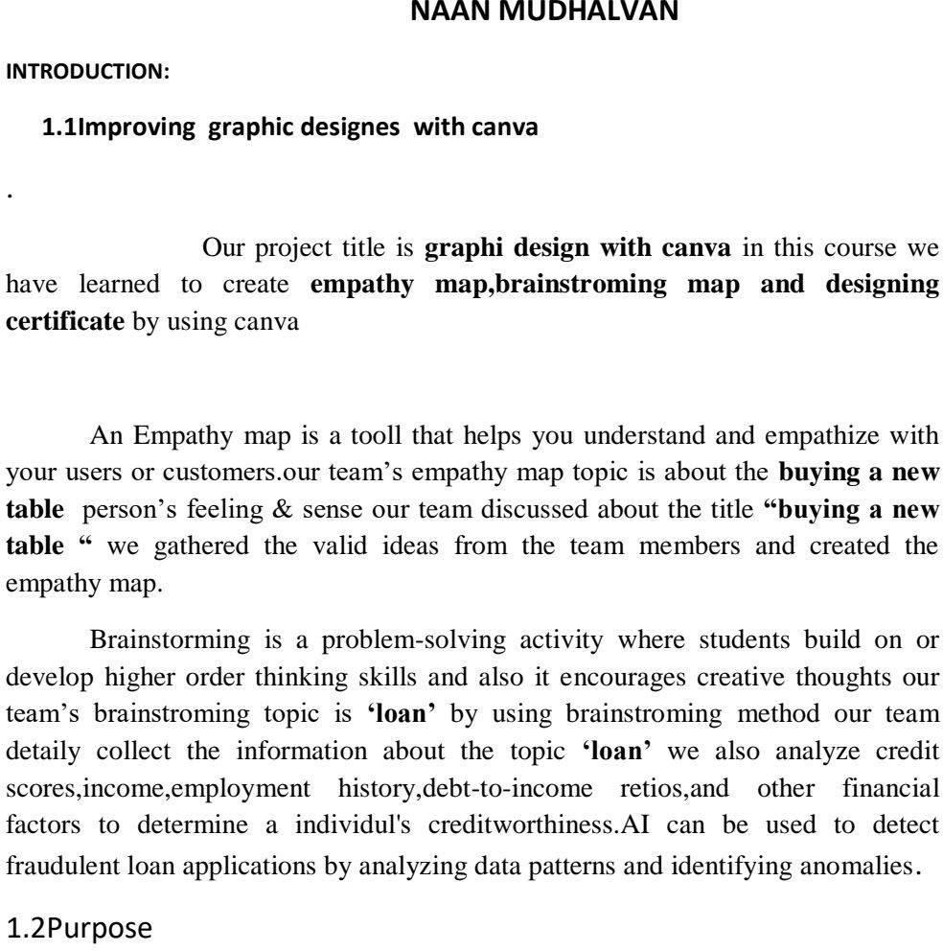

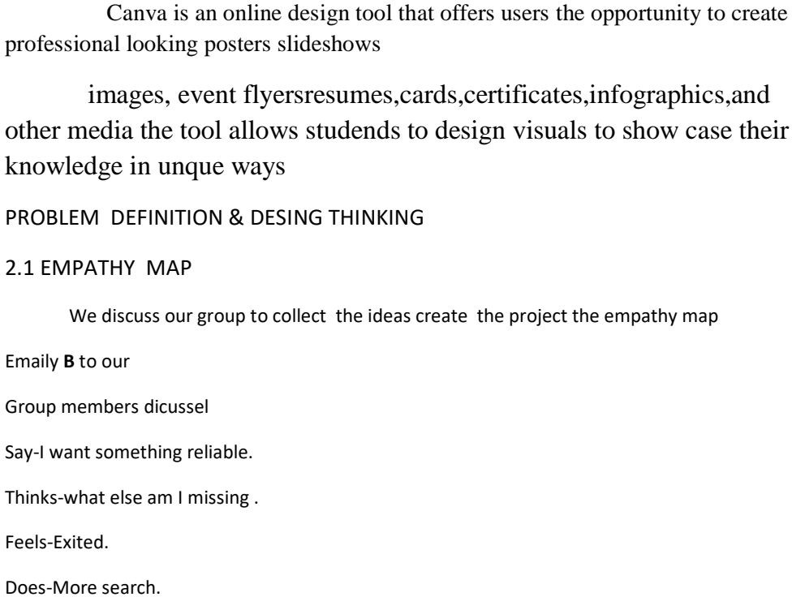

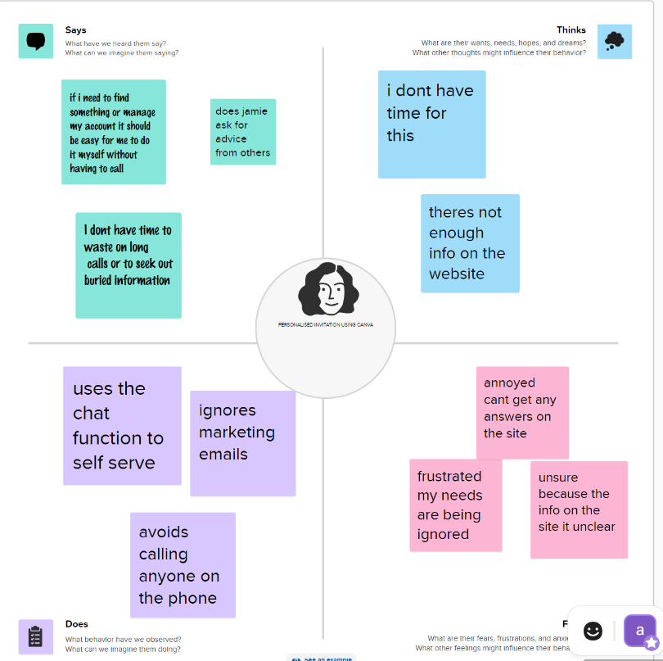

2.2 Ideation & Brainstroman:

We discuss our group to collect the ideas ctreate the project the brainstroming map group members dicussel say- I want something reliable. Thinks what else am I missing. Feels exited. Does more search

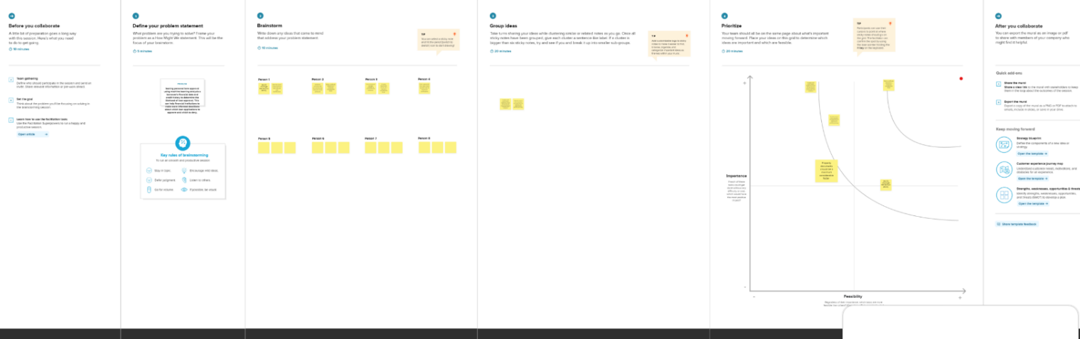

Project management

The planning and organizing of a company’s resources to move a specific tesk, event or duty toward completion.

Human capital

We need investment in human capital to produce more human capital out of human resources

Team Building

Most organization are trying to develop a sprit of teamwork improve

Aim ought to clear ,brief and direct

Maintain eye contact facial expressions mirror your feelings and how you’re feeling right now



